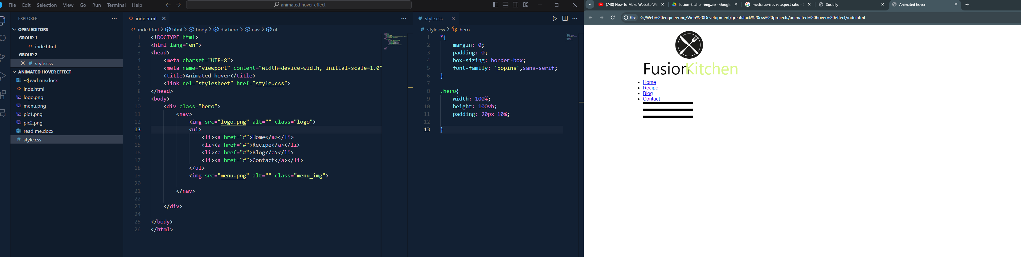

We can see logo links and menu icon img

Flex akare shajalam nav and cursor dile pointer dekhabe img e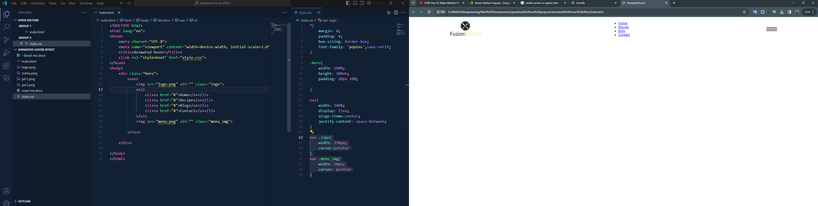

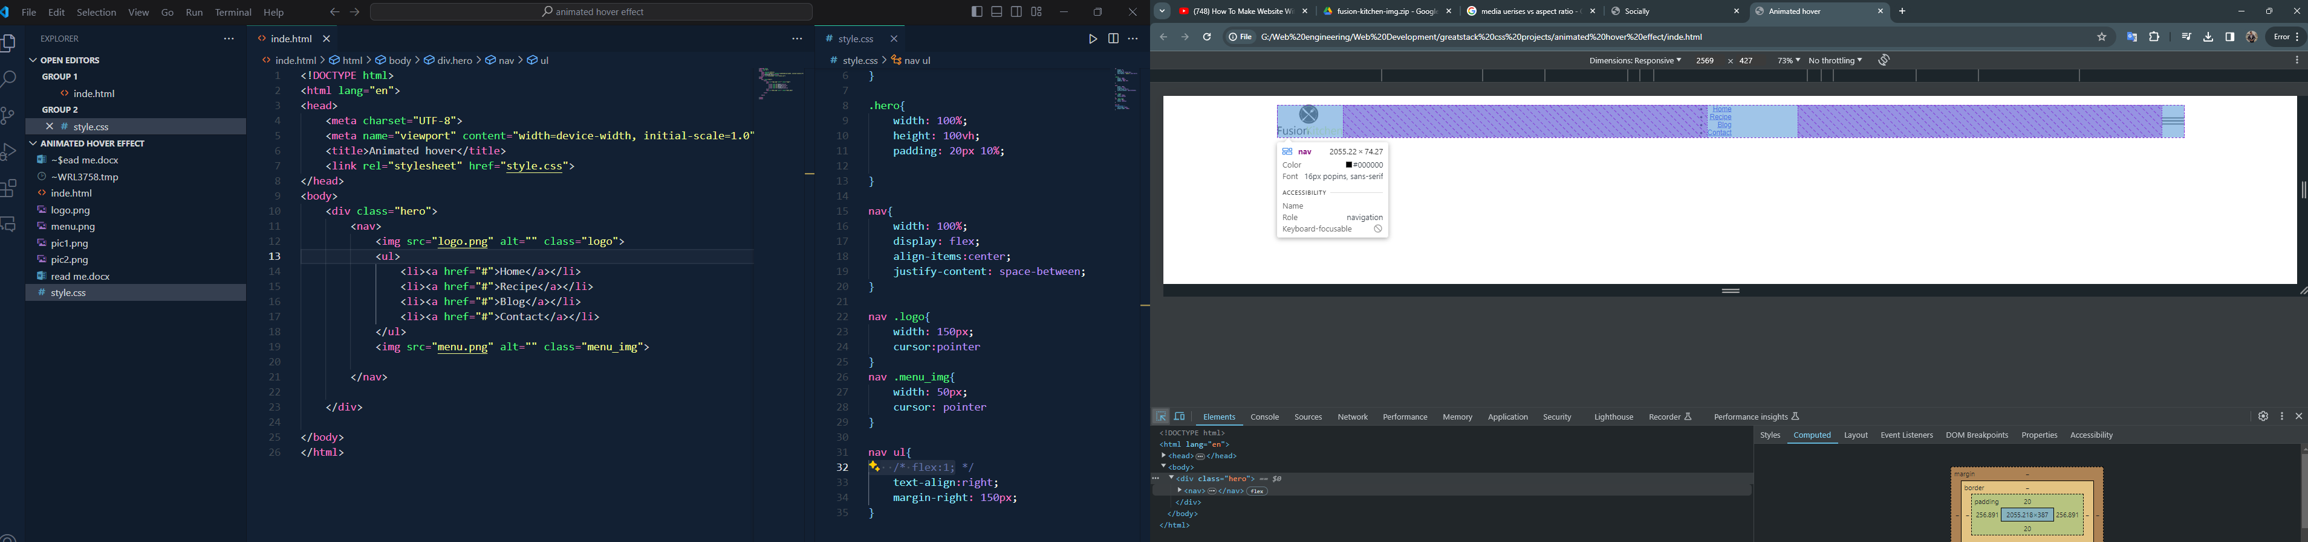

Flex 1 dewar age 3 take 3 bhaag korse ami chacchi j majher ta pura jayga khabe oi 2 ta element k pashe rekhe SPACE BETWEEN ER PURA JAYGA KHEYE FELSE FLEX 1 DEWAR KARONE

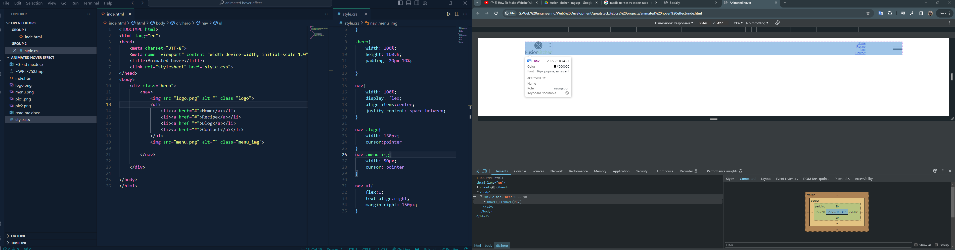

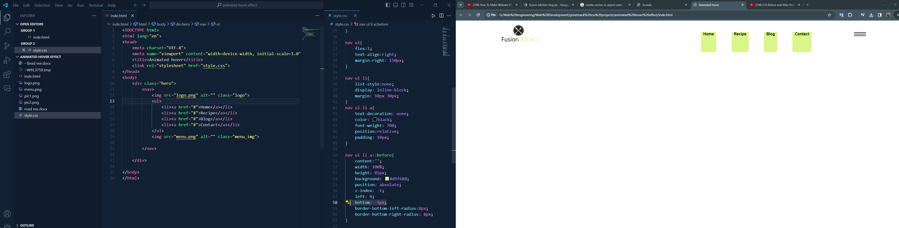

Animated background color

